TC-DISP-006
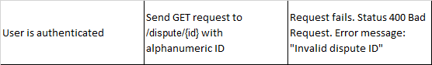
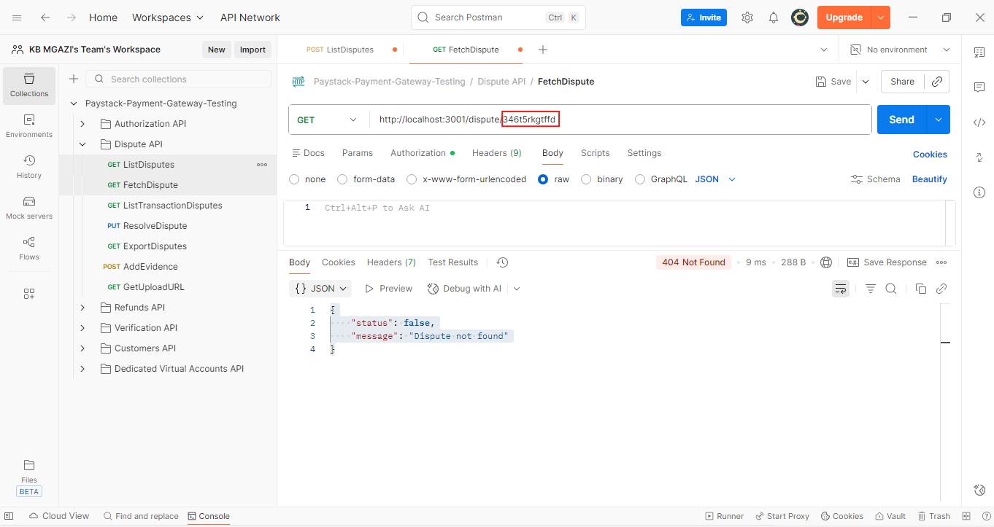
Response:
{
"status": false,
"message": "Dispute not found"
}

